CLASSI III
Plesso Paolo Rossi, Fabriano, Corinaldo e Pennabilli
MATEMATICA
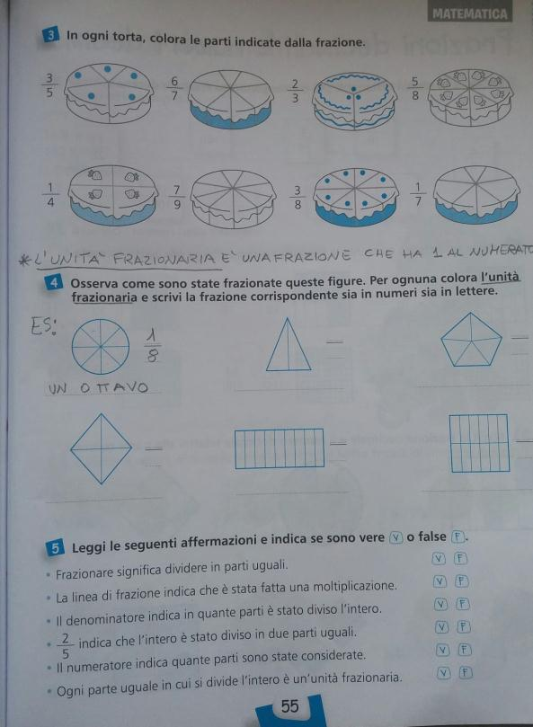
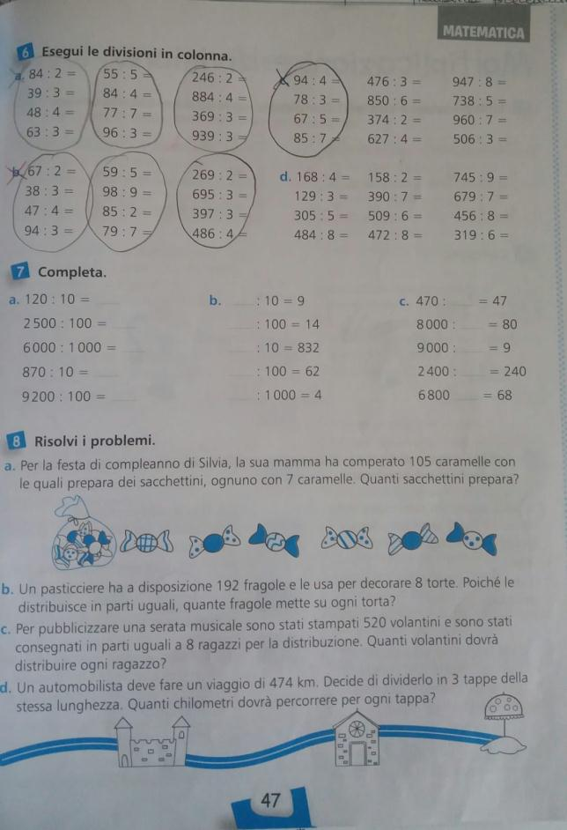

https://www.youtube.com/watch?v=Hu3C2wylA30&t=22s
https://www.youtube.com/watch?v=tTB4WdD4H9E&t=25s
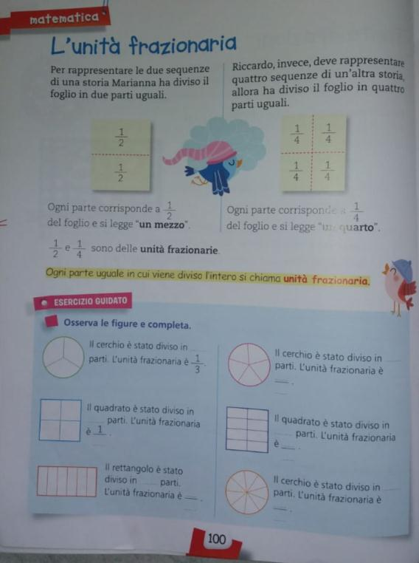

Trova il fattore mancante:  6 x __________ = 36  7 x __________ = 14  8 x __________ =40  5 x __________ = 30  9 x __________ = 27  4 x __________ = 16  3 x __________ = 12  10 x __________ = 50 | Trova il divisore:  30 : _________ = 5  48 : _________ = 8  35 : _________ = 7  72 : _________ = 8  16 : _________ = 4  18 : _________ = 2 | Trova il dividendo:  _________ : 2 = 4  _________ : 6 = 6  _________ : 2 = 3  _________ : 4 = 7  _________ : 2 = 6  _________ : 7 = 5

https://www.youtube.com/watch?v=wCpECwUaiI4&t=35s
https://www.youtube.com/watch?v=wjCsODe8Lu0&t=44s
https://www.youtube.com/watch?v=wCpECwUaiI4&t=93s

Storia
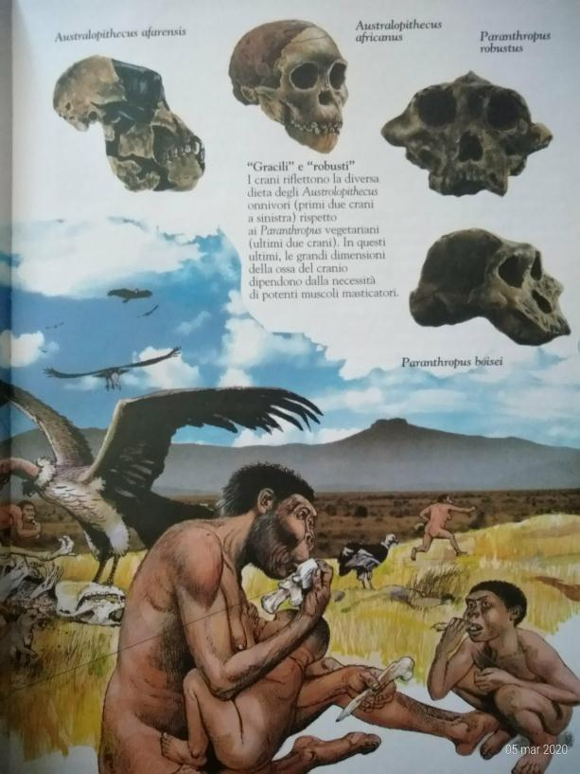
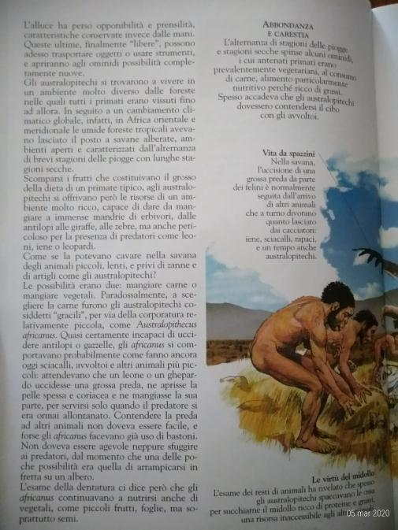
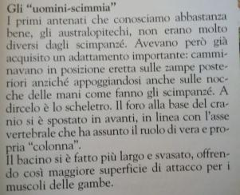
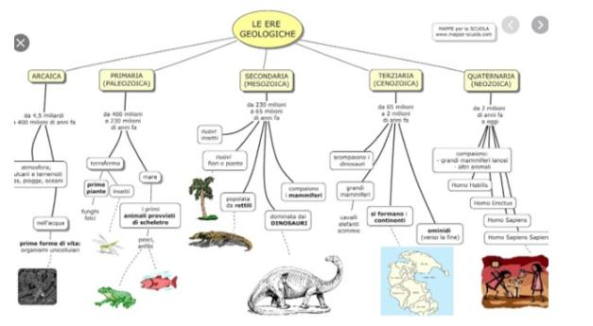
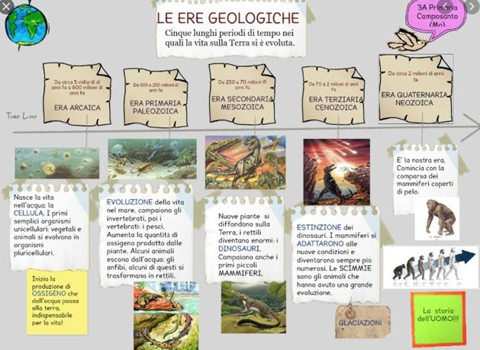

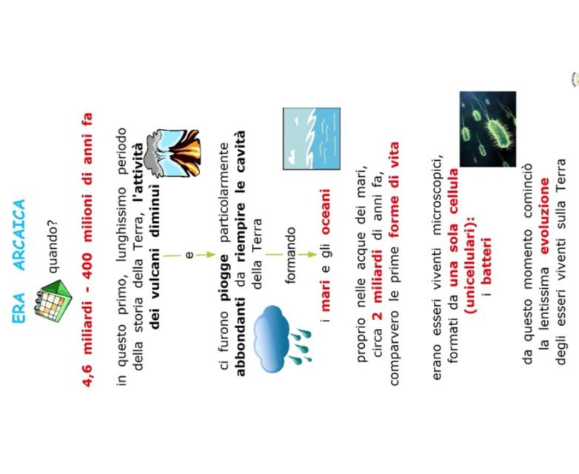
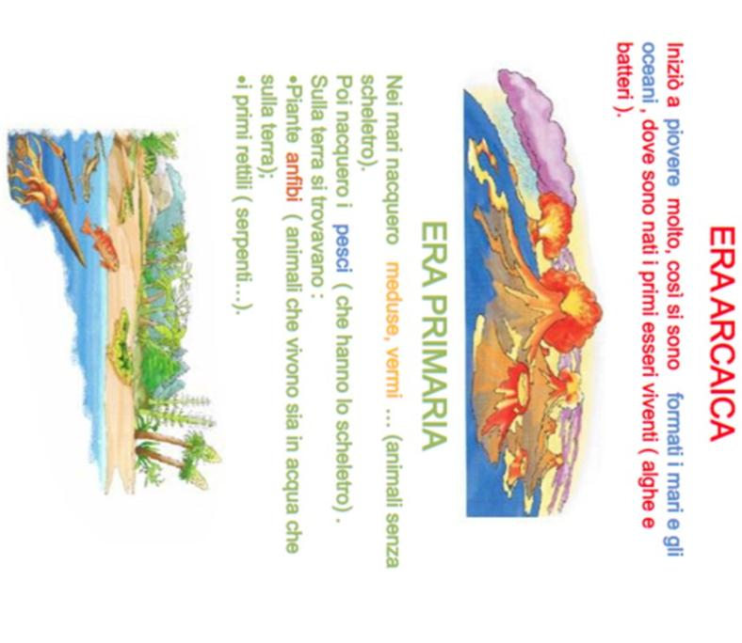
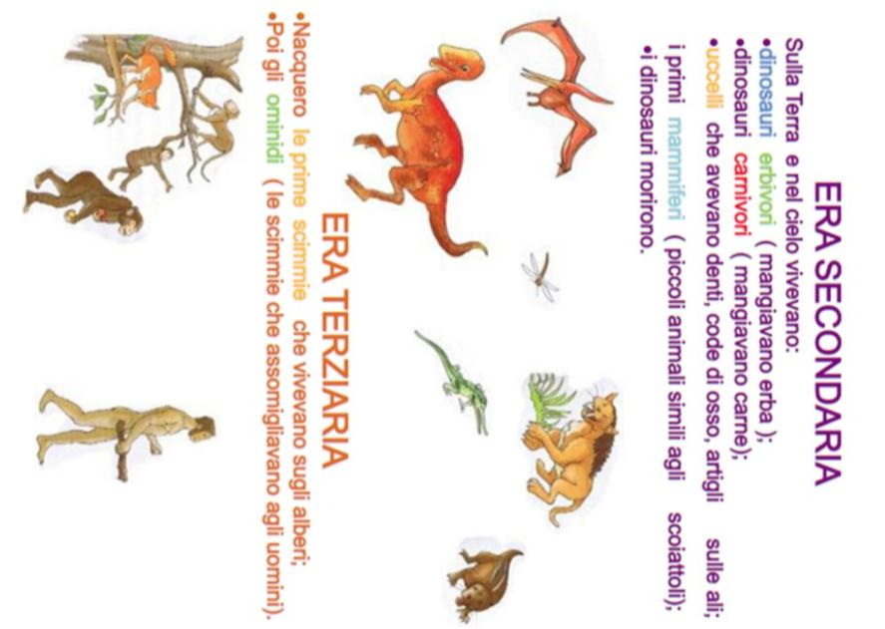

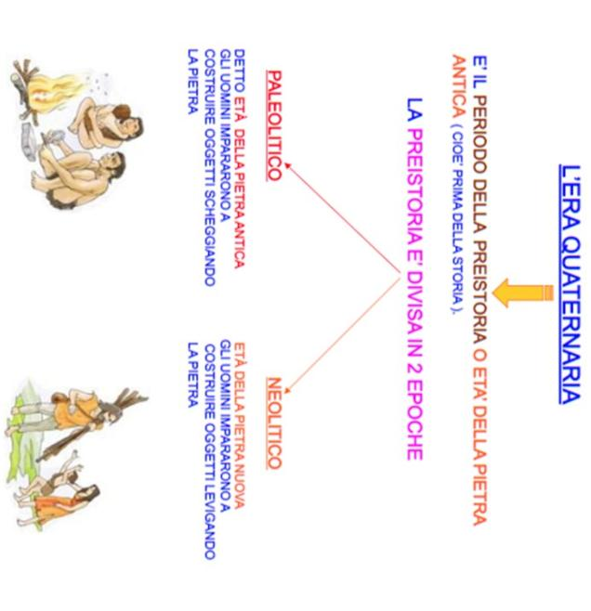

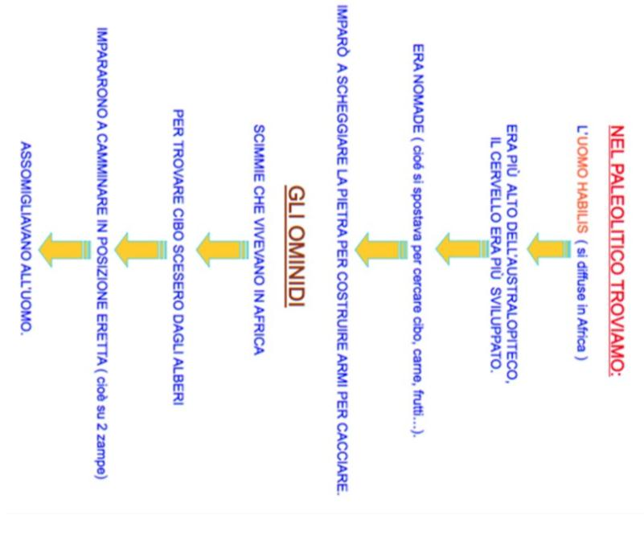

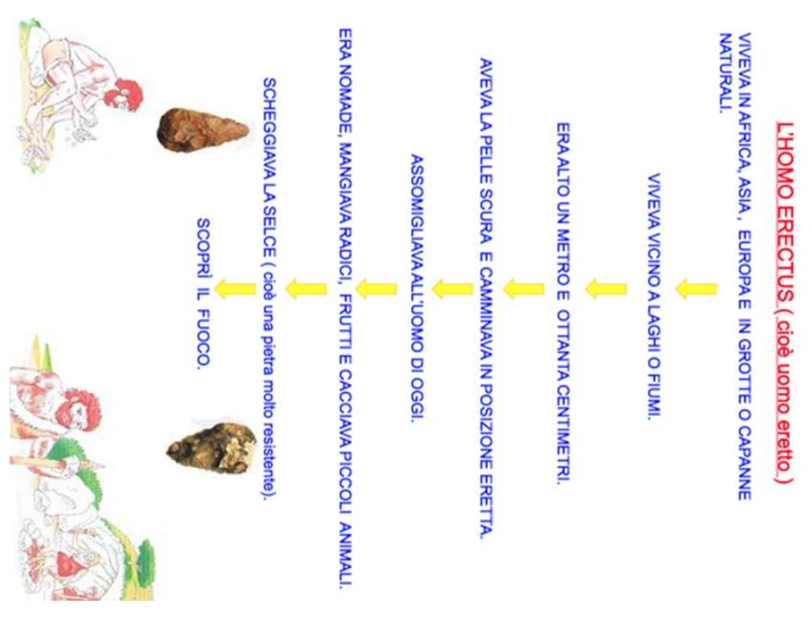

https://www.youtube.com/watch?v=R4pAUVbIo2E&list=PLAYDvzEJ0_NLMoL0emGT8rioRRql0d_vr

https://www.youtube.com/watch?v=HvGsnBMx1RY&list=PLAYDvzEJ0_NLMoL0emGT8rioRRql0d_vr&index=3

https://www.youtube.com/watch?v=U4Xs-5F_tnQ&list=PLAYDvzEJ0_NLMoL0emGT8rioRRql0d_vr&index=4

https://www.youtube.com/watch?v=_SmB39jqkx0&list=PLAYDvzEJ0_NLMoL0emGT8rioRRql0d_vr&index=5

https://www.youtube.com/watch?v=3EW0fwLnXPc&list=PLAYDvzEJ0_NLMoL0emGT8rioRRql0d_vr&index=6

https://youtu.be/qTl1tu1da54

Geografia
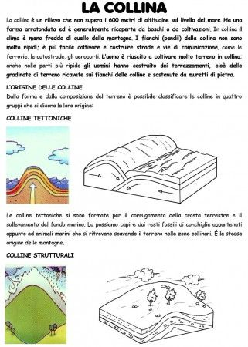
https://www.youtube.com/watch?v=hD7Z205kqyc
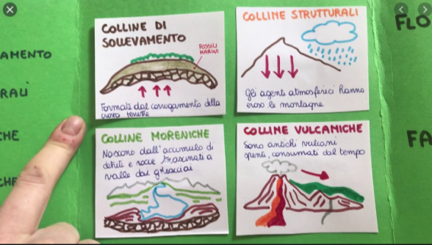

https://www.youtube.com/watch?v=k4I4GOJSguE
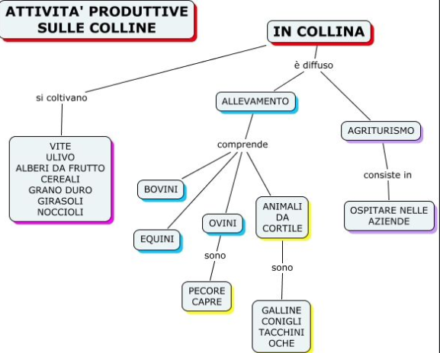
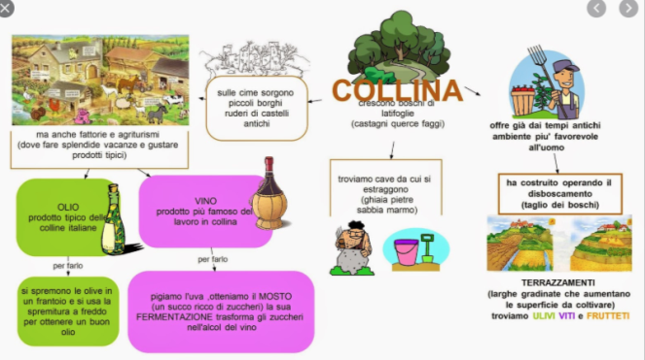https://www.youtube.com/watch?v=ezHSmijCP4M
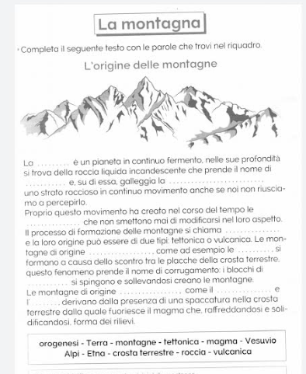

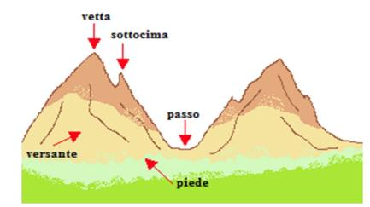

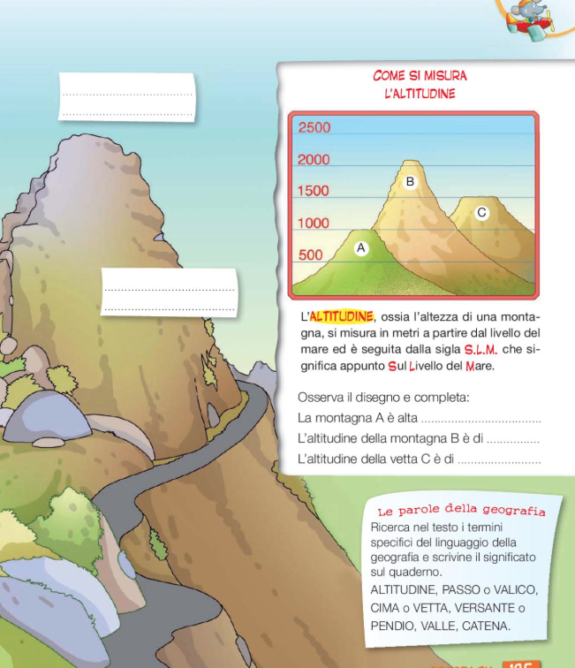

https://www.youtube.com/watch?v=-QOZV_KJ7pQ
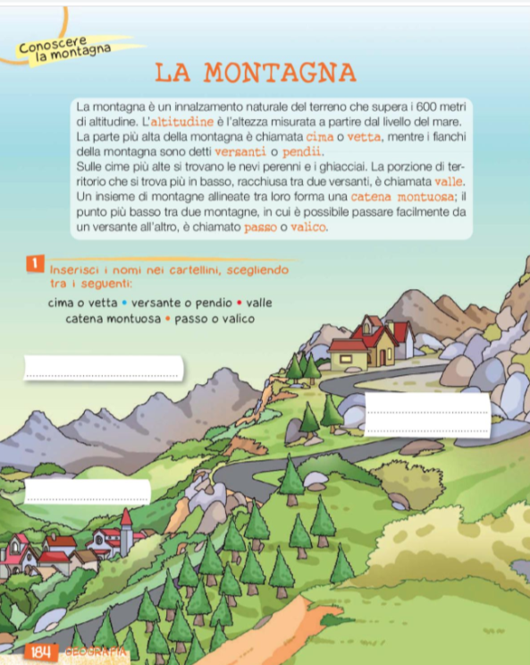
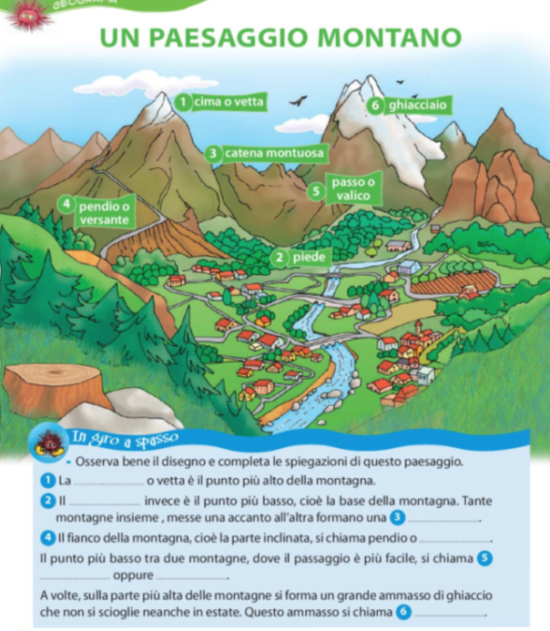

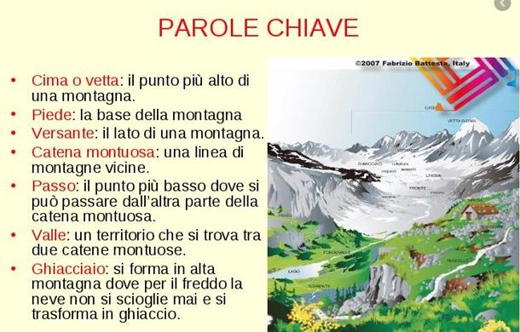

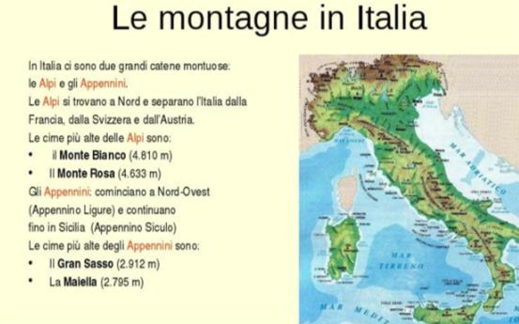
https://www.youtube.com/watch?v=L4P---Mkqt8
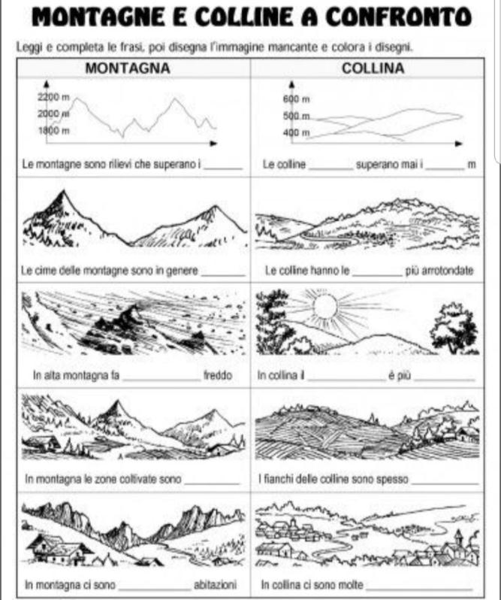
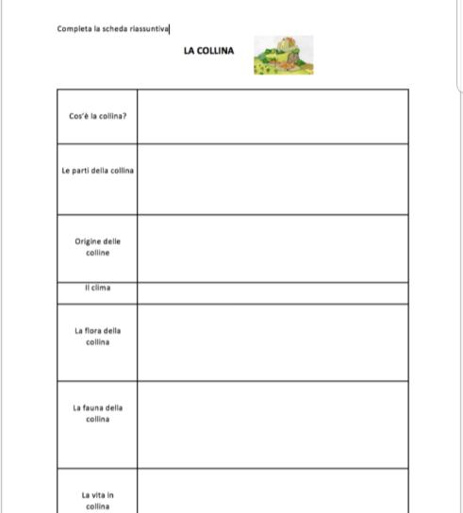
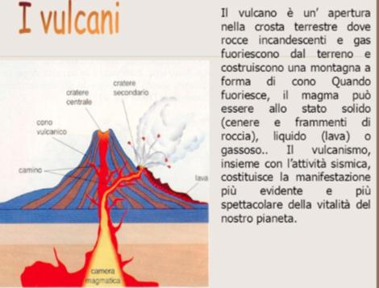
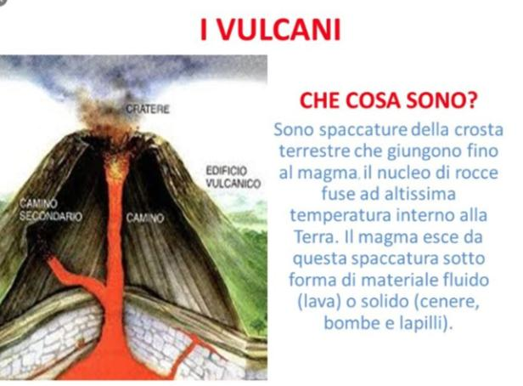

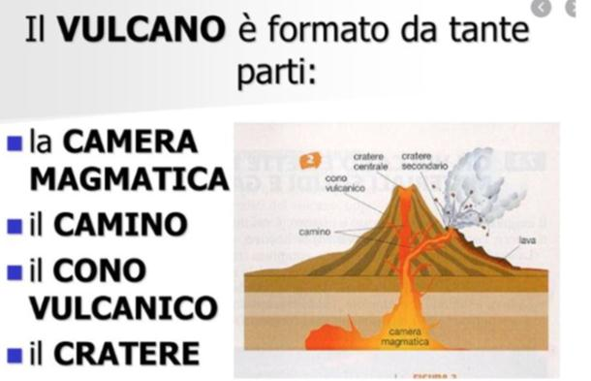
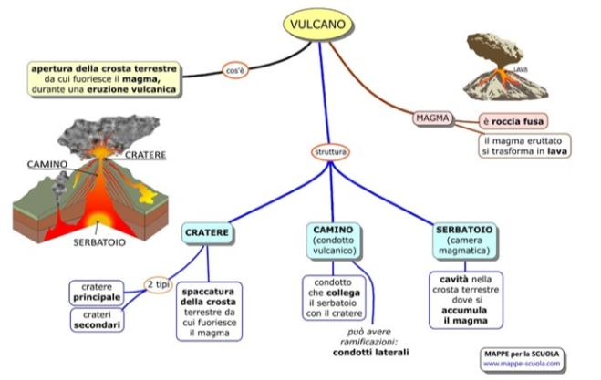

https://www.youtube.com/watch?v=Vp3-3DhFAa0

https://www.youtube.com/watch?v=91wDm7swnFw

https://www.focusjunior.it/scienza/ambiente/vulcani/vulcani-come-sono-fatti-dove-si-formano-perche/
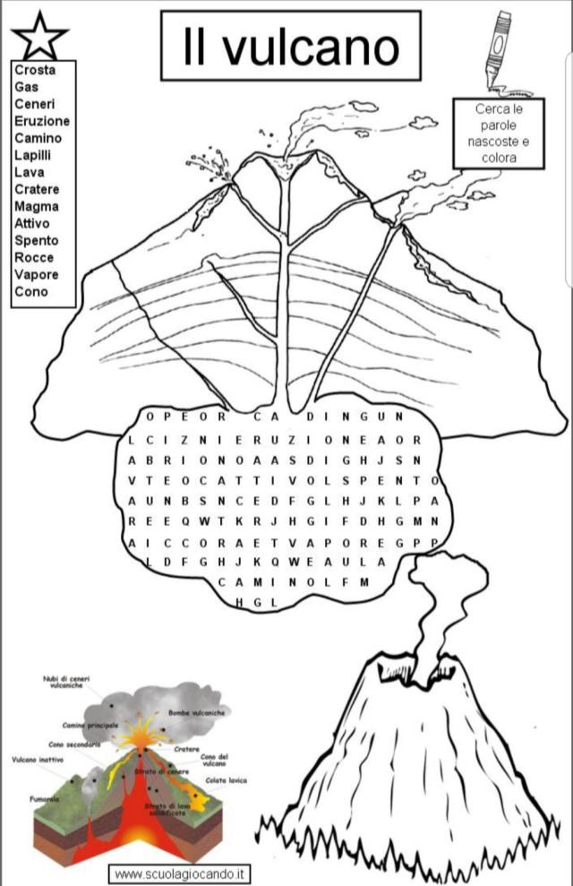
INGLESE
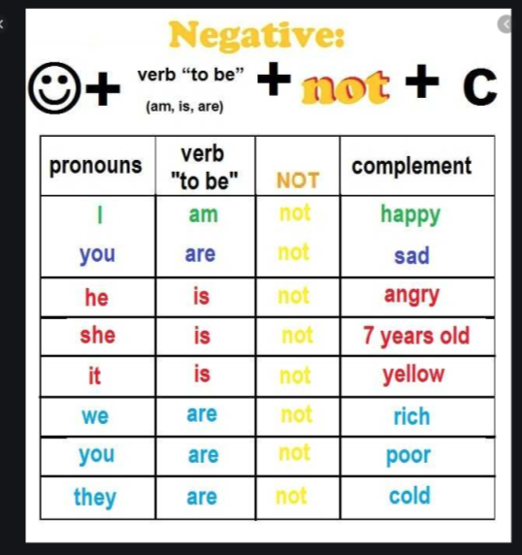
https://www.youtube.com/watch?v=Ia0FgQNilfY
https://www.youtube.com/watch?v=JLIO2LD2Cds
https://www.youtube.com/watch?v=nZl55OiJPO8
https://www.youtube.com/watch?v=PZCcRzgrr8Y

