PLESSO PENNABILLI –Classe 2A-ITALIANO-STORIA
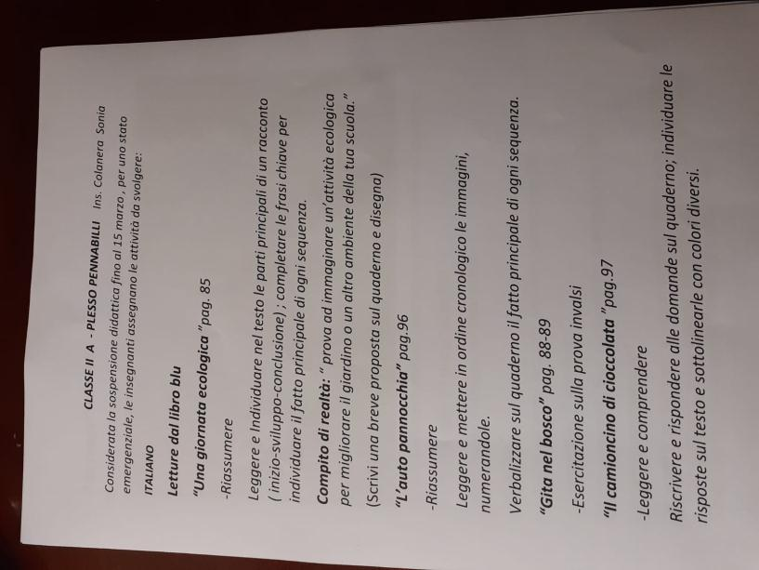
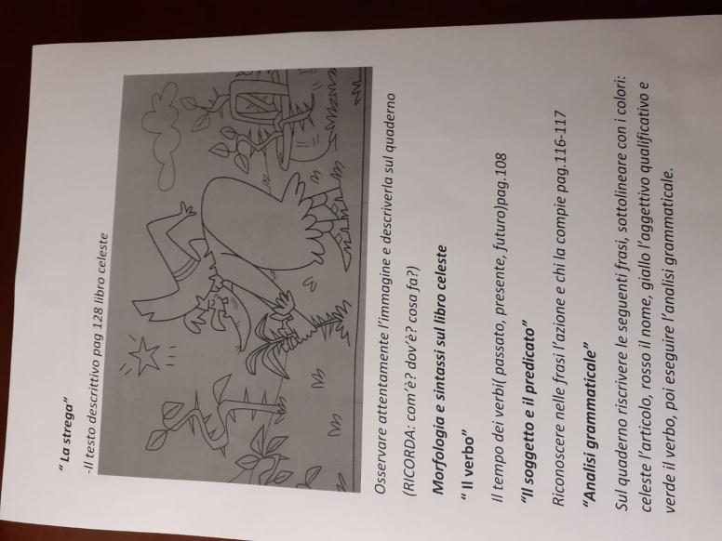

https://www.youtube.com/watch?v=ia38frQjjcU

https://www.youtube.com/watch?v=HK7VJK6c2w4

https://www.youtube.com/watch?v=J8lEe7zbv48

https://www.youtube.com/watch?v=DwKaVPb17yA

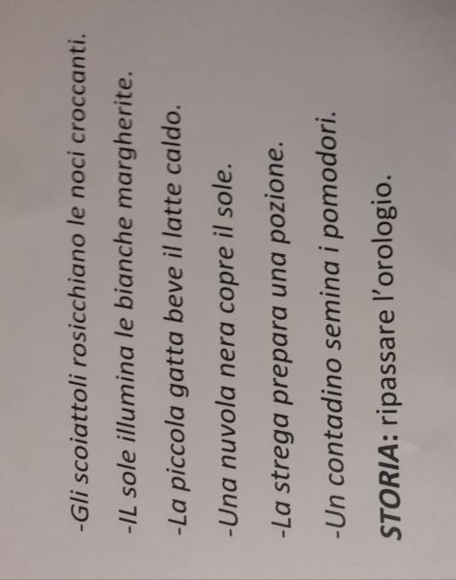

PLESSO PENNABILLI –Classe 2A-MATEMATICA
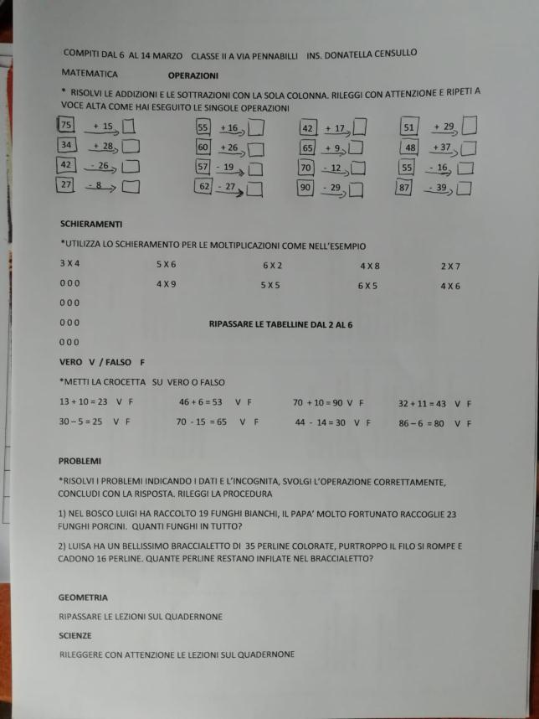
https://www.youtube.com/watch?v=T2gZrMQS9rA

https://www.youtube.com/watch?v=nH8PvN7mSO4

https://www.youtube.com/watch?v=Ul-zSASe1Yo

https://www.youtube.com/watch?v=T5T5A3KYhvg

https://www.youtube.com/watch?v=fjnehagaJyU

https://www.youtube.com/watch?v=Tnh_NrpIBE8

https://www.youtube.com/watch?v=Y3dBIQ2U5Bk

https://www.youtube.com/watch?v=api6UtUvK-g

https://www.youtube.com/watch?v=684Z1KC9bMo

PLESSO CORINALDO –Classe 2A-MATEMATICA
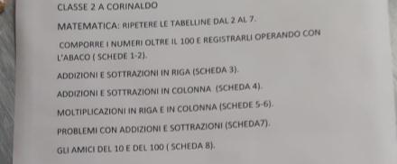
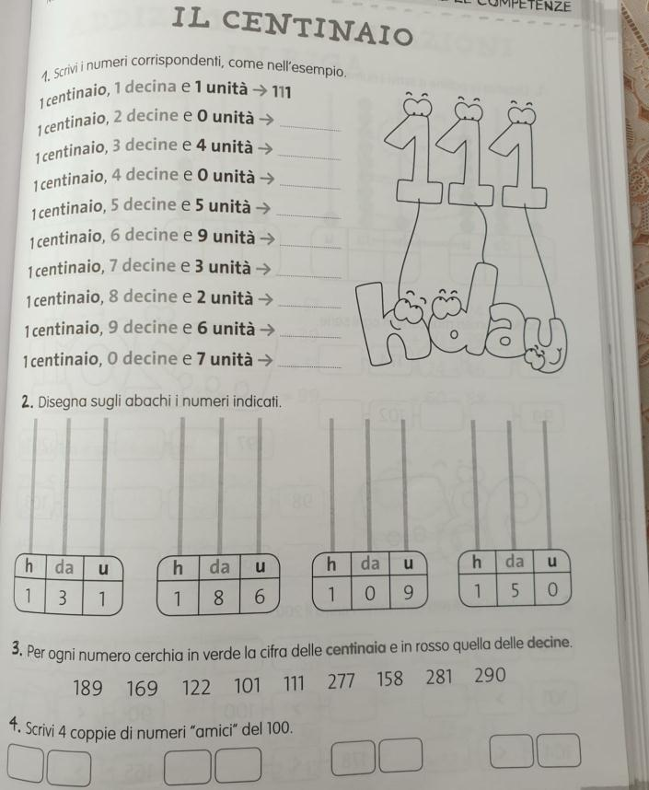
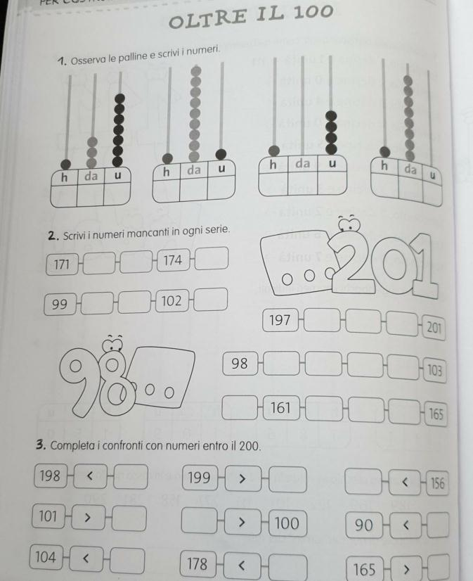
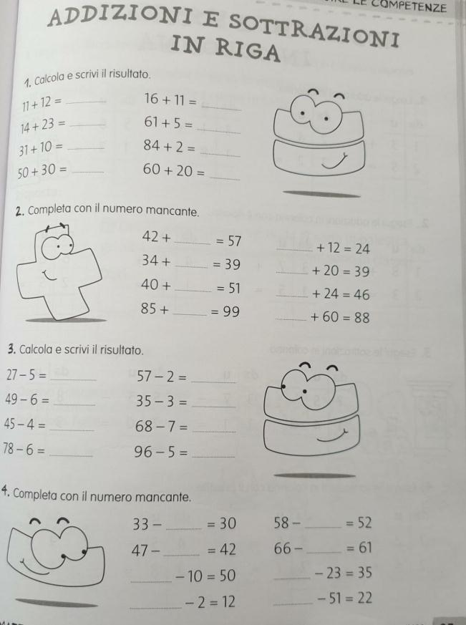
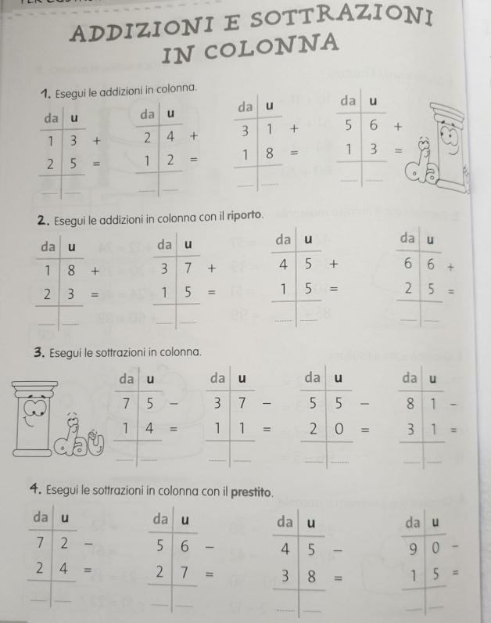
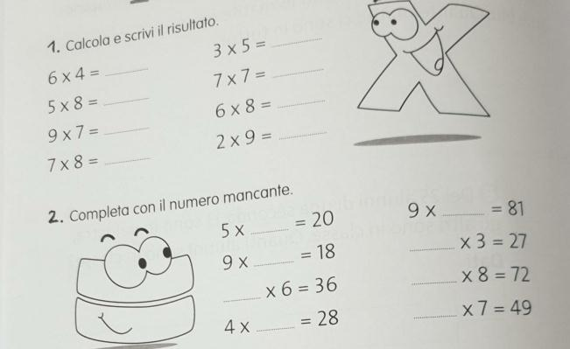
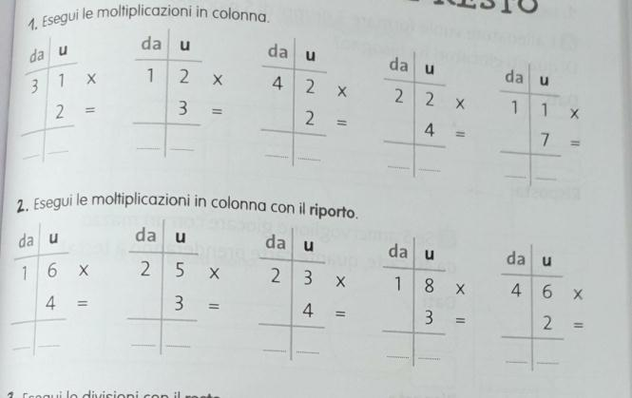
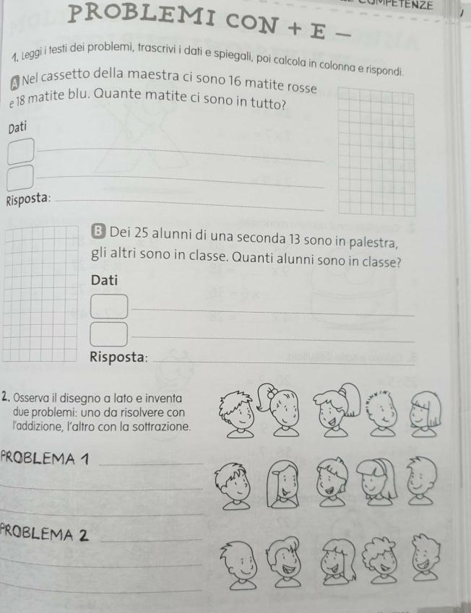
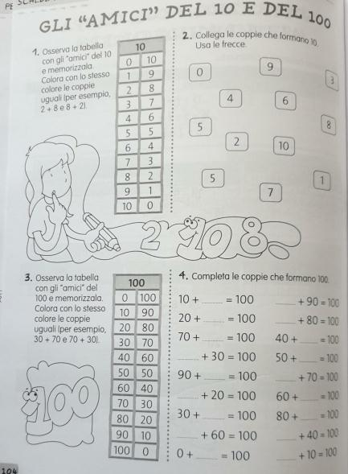
PLESSO CORINALDO –Classe 2A-ITALIANO
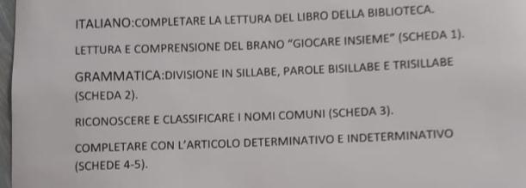
https://www.youtube.com/watch?v=OVNsx7MGffA

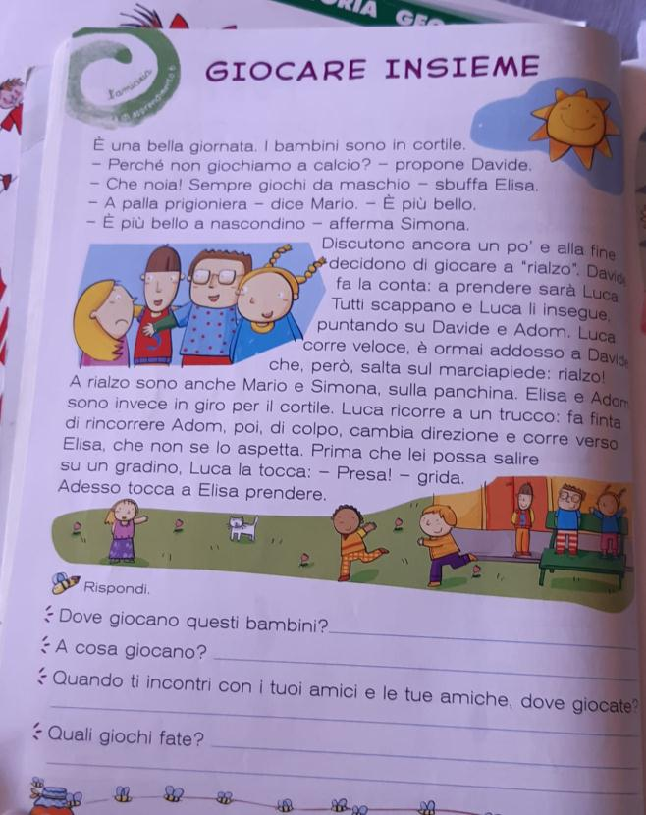
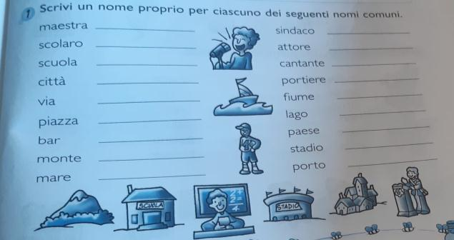
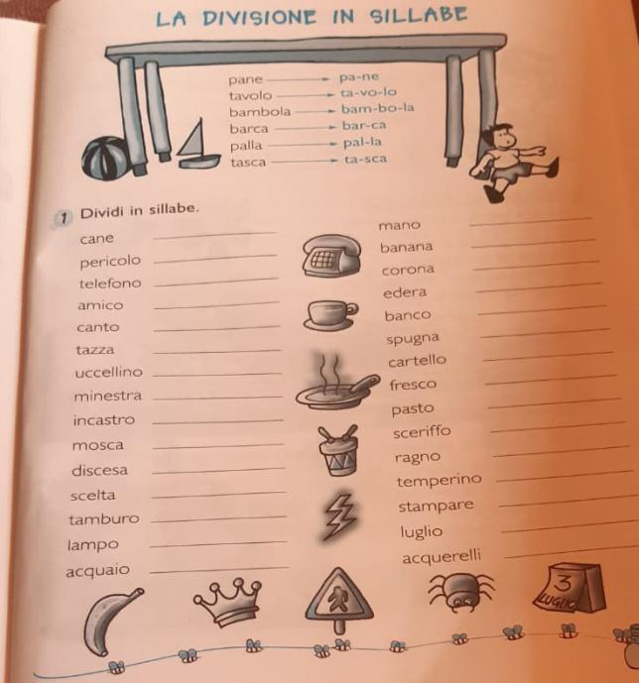
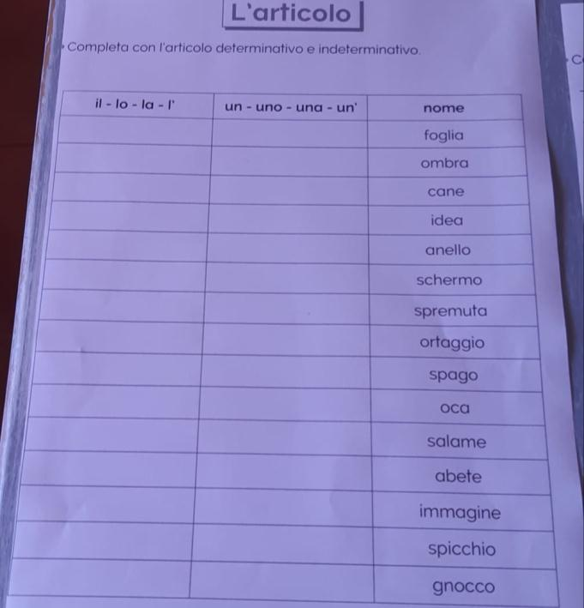
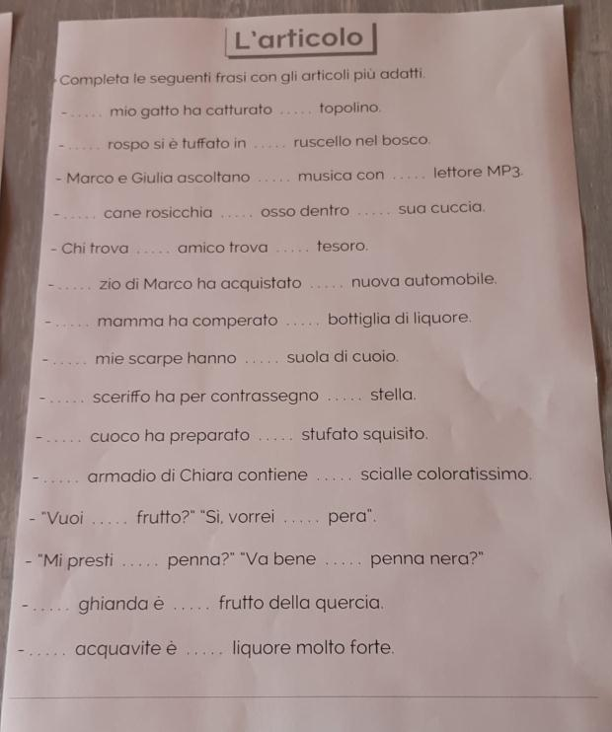
PLESSO FABRIANO-Classe 2A
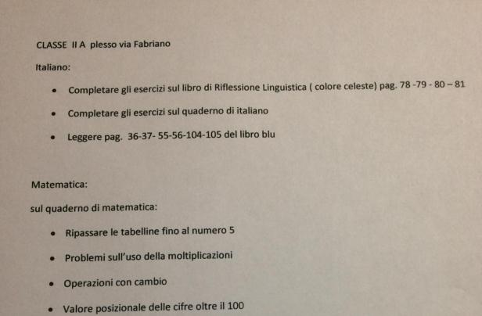
PLESSO PAOLO ROSSI-Classe 2A
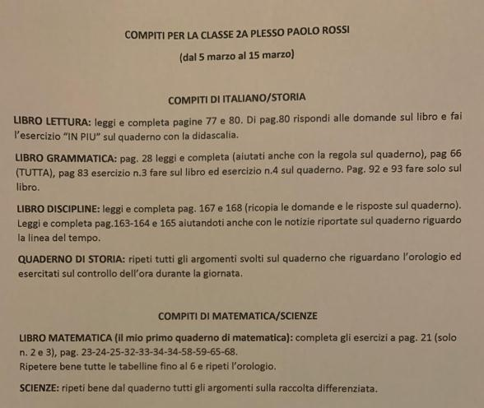
https://www.youtube.com/watch?v=6n7wX-JxwKo

https://www.youtube.com/watch?v=uVL_Qcjqpjw

https://www.youtube.com/watch?v=zw1rxhy3dpU&list=PLCd2m2rFdKiSO9nENfpRWi02maoJCKLKb

https://www.youtube.com/watch?v=0vnIXkFeBkw

https://www.youtube.com/watch?v=CAb9v7rPMeU

https://www.youtube.com/watch?v=kwrgHzGMZts

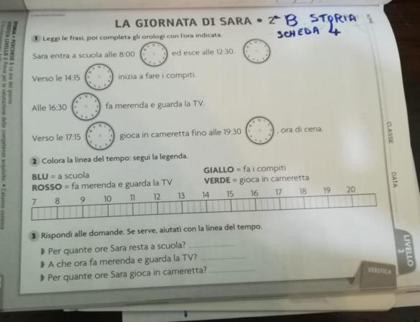
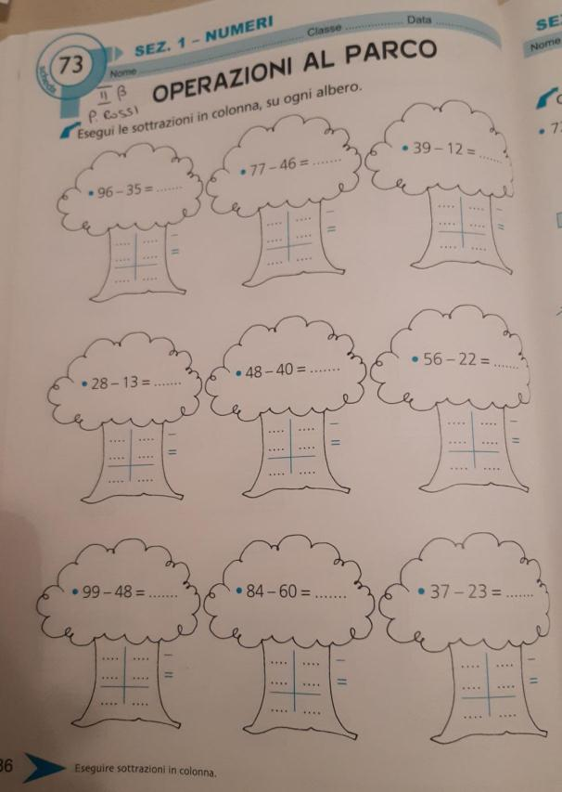
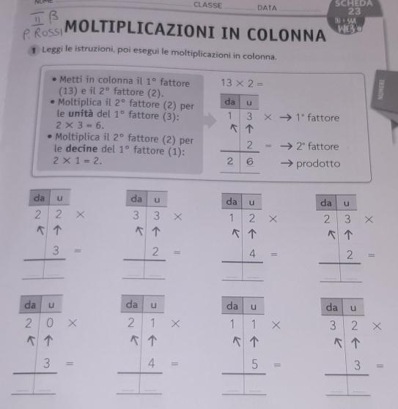
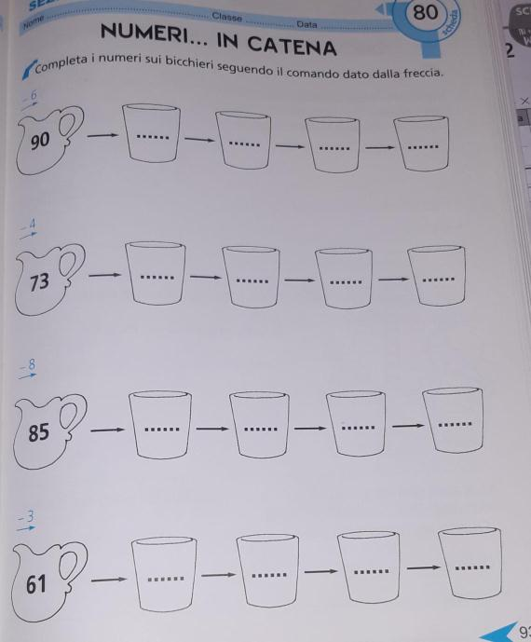
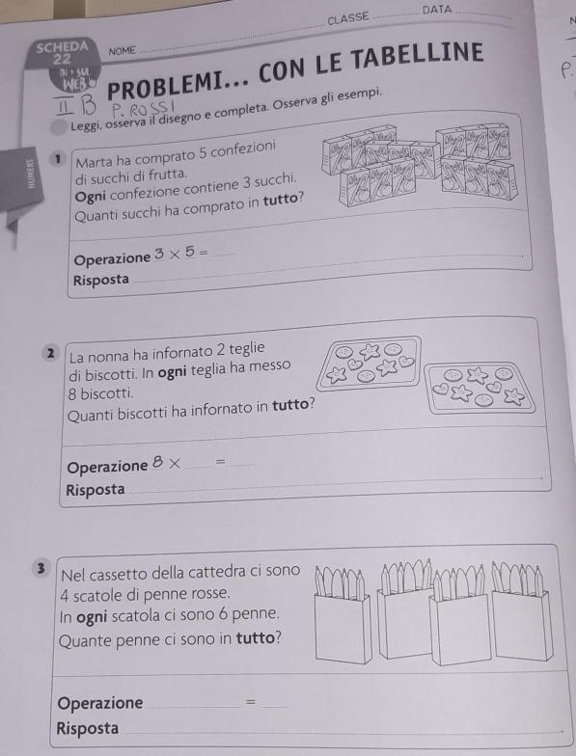
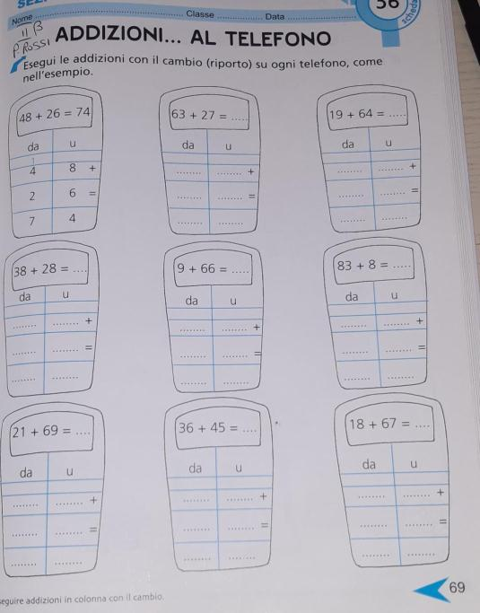
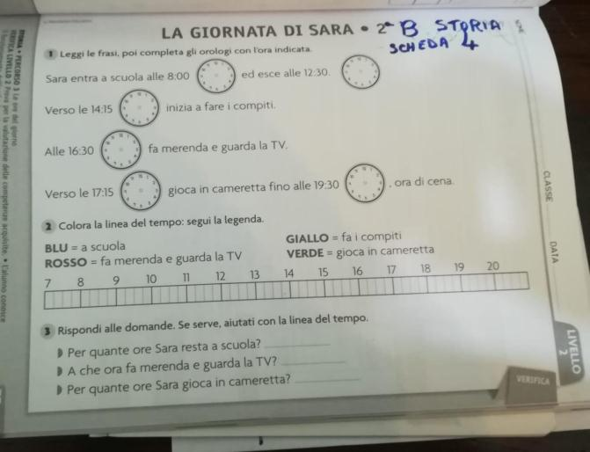
https://www.youtube.com/watch?v=6n7wX-JxwKo
https://www.youtube.com/watch?v=uVL_Qcjqpjw
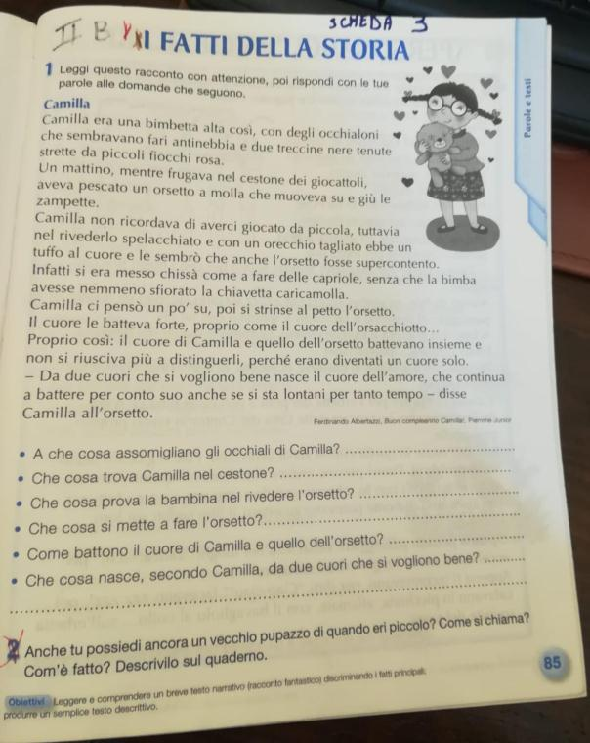
https://www.youtube.com/watch?v=zw1rxhy3dpU&list=PLCd2m2rFdKiSO9nENfpRWi02maoJCKLKb

https://www.youtube.com/watch?v=0vnIXkFeBkw
https://www.youtube.com/watch?v=CAb9v7rPMeU
https://www.youtube.com/watch?v=kwrgHzGMZts

